Analog to digital conversion

# Intro:

An analog signal is a signal that is continuously in time and in amplitude. The resolution is by definition infinitely. When an analog signal is made digital does this mean that we need to discretize the signal. A discrete digital signal is the counterpart of a continuous signal. To make it digital we need to take a moment and save it. Then take the next moment and save it again. This happens at a certain frequency. That frequency is called the sampling frequentie. Every moment there will be a sample of the sound, and many sounds after each other will result in a more or less smooth signal. The higher this sample frequency, the higher the resolution of the sound.

# Working

The analog signal is coming into the AD-converter and will be edited by a low pass filter. This is done for preventing aliasing. This occurs when the sample frequentie isn’t at least two times higher then the highest frequentie. If the sound frequency is too high in relation to the sample frequency, you get audio with horrible sound in the high frequencies. So our sample frequency must be high enough to pass high frequency sound (20kHz). So we need to sample at least 40.000Hz, or the standard sampling frequency of 44.100Hz. After this low pass filter the ADC takes samples at the sample frequency. This means that we are going to look at the exact amplitude of the sound wave. Well known systems are the voice telephony with a sample rate of 8kHz. So the maximal frequency we can sample is 4kHz (due the aliasing low pass filter). Every sample, every amplitude is a number that contains bits. The amount of bits determines how exactly the signal is measured. And that’s logical. Because if you have to divide a signal over 8 bits. Or you have to divide that same signal over 32 bits. The precision of the 32 bits is four times better then the 8 bits. When the analog signal is filtered and quantized. The analog signal has become digital.

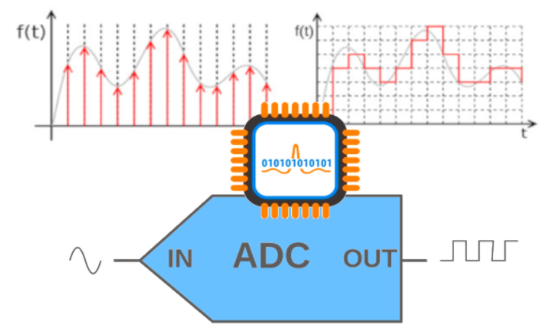

## 

## Summary

* The analog input is quantized in digital amplitudes.
* The more refined the quantization. The higher the amount of bits needed.
* The bigger the amount of bits per amplitude the exacter the signal.
* The bigger the sample frequency, the bigger is the highest frequency without aliasing

## The implementation

Sampling uses a “sample-and-hold circuit”. At fixed time a sample is made from the analog signal. You can see it as a switch that turns on and off at fixed times. And a capacitor is used for holding the “memory” of that one amplitude.

That amplitude is compared to fixed levels. Here is a rounding error. This is the quantisation noise. The network to do this is a series circuit of four resistors where a reference voltage is applied to. After the first resistor you have 25% of the voltage. After the second one you have 50%, after the third 75% and after the fourth 100% of the voltage. These levels are together with the sample connected to a differential amplifier.

* If the sample amplitude is bigger then 25%, the output of the first differential amplifier changes polarity
* If the sample amplitude is bigger then 50%, the output of the second differential amplifier changes polarity
* If the sample amplitude is bigger then 75%, the output of the third differential amplifier changes polarity
* If the sample amplitude is bigger then 100%, the output of the fourth differential amplifier changes polarity

And last but not least you have a logic circuit which is granting binary numbers to the signal.

* Level 1 is 00(2)
* Level 2 is 01(2)
* Level 3 is 10(2)
* Level 4 is 11(2)

## Improve the quality

* Increase the amount of samples per second
* Increase the amount of bits per sample
* Faster sample-and-hold circuit
* More extensive networks
* Every bit extra is a doubling of the amount of resistors needed
* The tolerance on the resistors must be as low as possible